**BRANDCHEFE ADVERTISING**

**1.TOTAL CLIENTS**

**SELECT count(Id) as Total_Employee FROM ClientMaster**

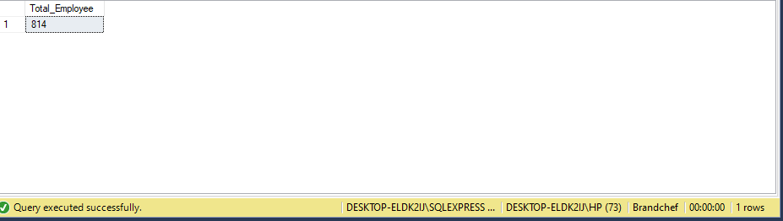

**2.**

**A] MAX ADS CLIENTS - EMEDIA**

**SELECT TOP 5 C.ClientName , COUNT(*) FROM ClientMaster AS C**

**INNER JOIN EMediaROMaster AS EM ON C.Id= EM.FKClientId**

**GROUP BY C.ClientName ORDER BY COUNT(*) DESC**

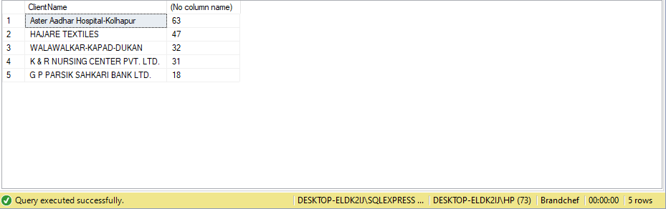

**B] MAX ADS CLIENTS - PMEDIA**

**SELECT TOP 5 C.ClientName , COUNT(*) as MAXAD FROM ClientMaster AS C**

**INNER JOIN PMediaROMaster AS PM ON C.Id= PM.FKClientId**

**GROUP BY C.ClientName ORDER BY COUNT(*) DESC**

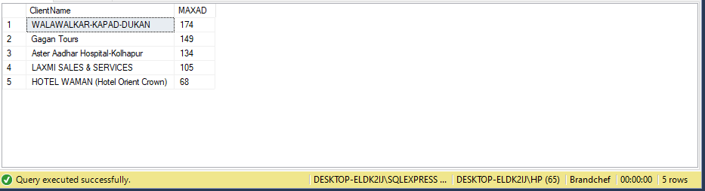

**3. MAX DISPLAY OF BROADCASTCENTERS**

**SELECT DISTINCT (BroadcastCenters), COUNT(BroadcastCenters) AS AD_AOUNT**

**FROM EMediaROMaster GROUP BY BroadcastCenters ORDER BY AD_AOUNT DESC**

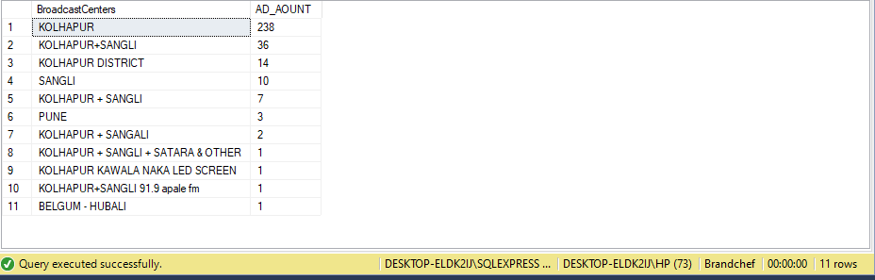

**4.**

**A] TOTAL PAYMENT AMOUNT COMPLETE / PENDING - EMEDIA**

**SELECT DISTINCT (Status), SUM(TotalCharges) FROM EMediaROMaster GROUP BY Status**

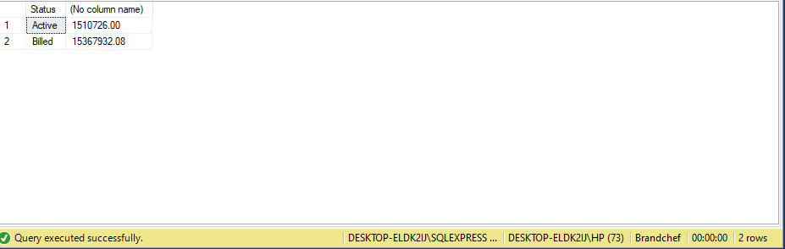

**B] TOTAL PAYMENT AMOUNT COMPLETE / PENDING- PMEDIA**

**SELECT DISTINCT (Status), SUM (TotalAmount) FROM PMediaROMaster GROUP BY Status**

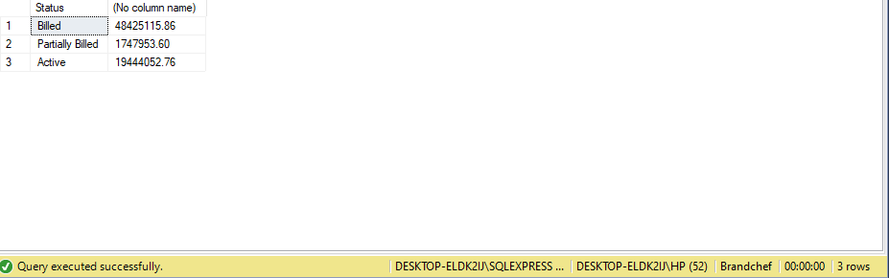

**5.**

**A] INCOME BY LOCATION**

**SELECT DISTINCT(BroadcastCenters), SUM(TotalCharges) INCOME FROM EMediaROMaster GROUP BY BroadcastCenters ORDER BY INCOME DESC**

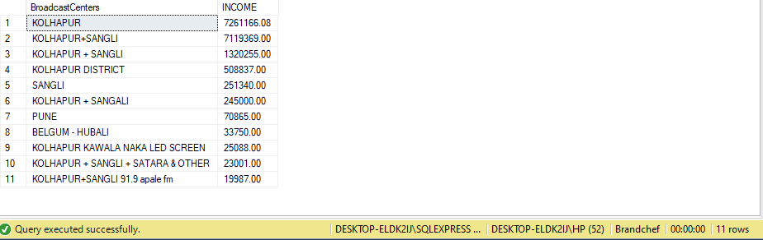

**B] TOTAL AMOUNT BY PAPER**

**SELECT PM.PaperName, SUM(M.TotalAmount) AS AMOUNT FROM PaperMaster AS PM**

**INNER JOIN PMediaROMaster AS M ON PM.Id = M.FKPaperId GROUP BY PM.PaperName ORDER BY AMOUNT DESC**

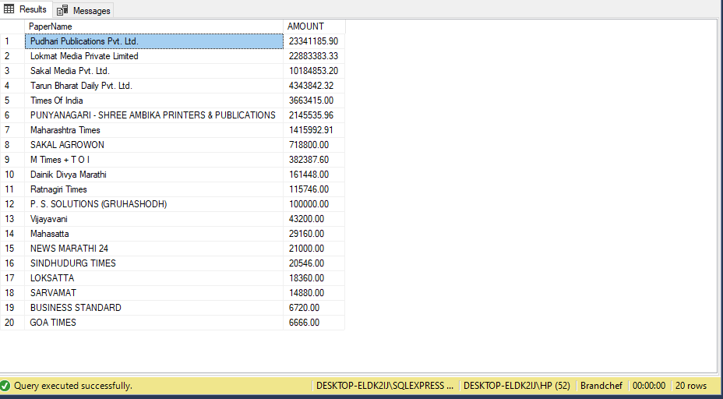

**6. ADS POINTS BY LOCATION**

**SELECT BroadcastCenters, COUNT(BroadcastCenters) FROM EMediaROMaster GROUP BY BroadcastCenters**

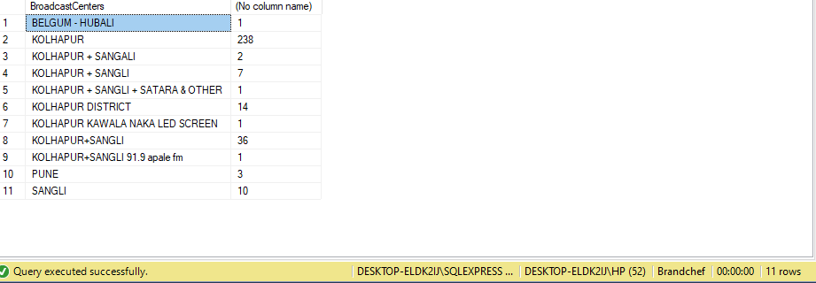

**7. MONTH WISE INCOME**

**SELECT YEAR(RODate) , SUM(TotalCharges) AS TCharge FROM EMediaROMaster**

**GROUP BY YEAR(RODate) ORDER BY TCharge DESC**

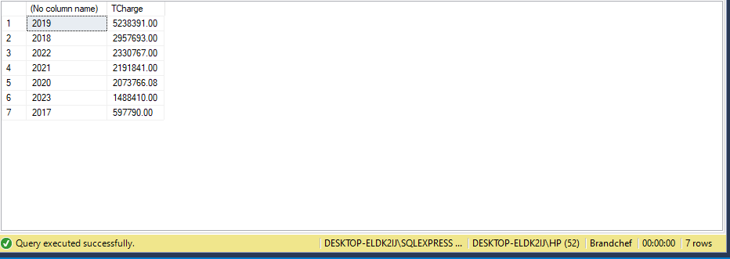

**8. TOTAL COMMISSION IN EMIDEA**

**SELECT SUM(ComissionAmount) FROM EMediaROMaster**

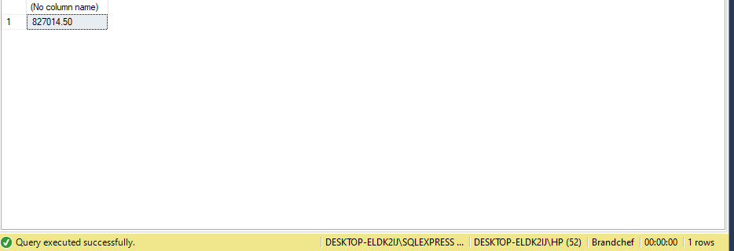

**9. A] YEAR WISE GST – EMIDEA**

**SELECT YEAR(RODate), SUM(CGSTAmount + SGSTAmount+ IGSTAmount) AS GST FROM EMediaROMaster GROUP BY YEAR(RODate)**

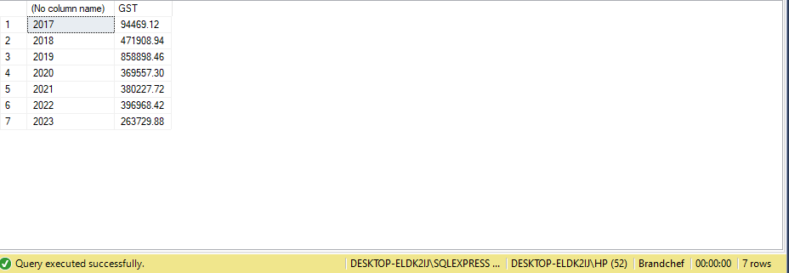

**B] YEAR WISE GST – PMIDEA**

**SELECT YEAR(RODate), SUM(GSTAmount) FROM PMediaROMaster GROUP BY YEAR(RODate)**

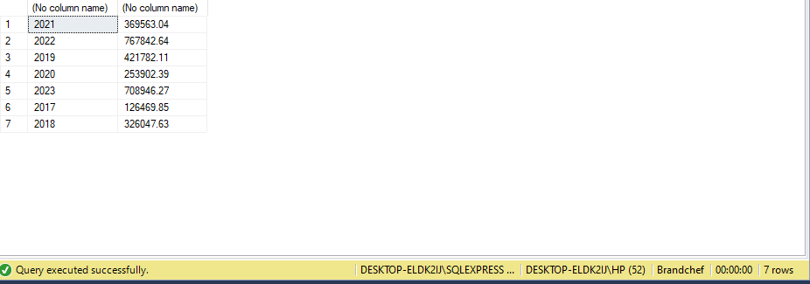

**10. TOP 30 CLIENTS BY MAX_DAY ADS**

**SELECT TOP 30 C.ClientName , SUM(PM.NoOfDays) AS DAYS FROM ClientMaster AS C INNER JOIN PMediaROMaster AS PM ON C.Id = PM.FKClientId GROUP BY C.ClientName ORDER BY DAYS DESC**

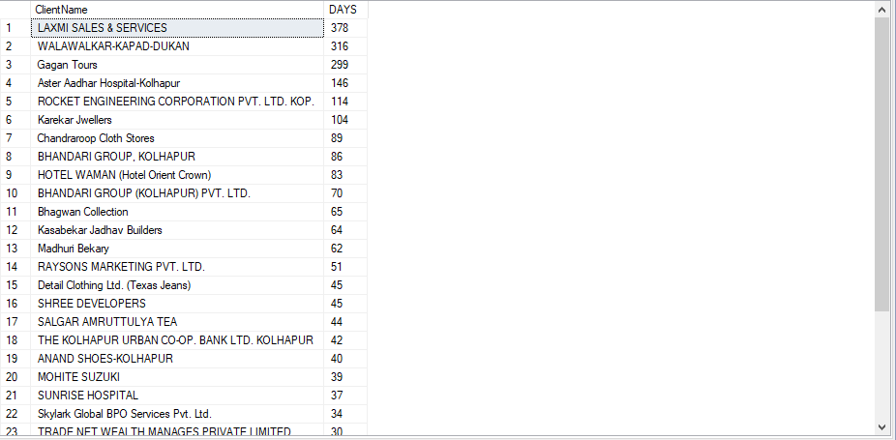

**11. PUBLICATION_NAME WISE COUNT OF ADS -EMIDEA**

**SELECT p.PublicationName, count(e.FKPublicationId) AS counts_ad FROM PublicationMaster AS p INNER JOIN EMediaROMaster AS e ON p.Id = e.FKPublicationId GROUP BY p.PublicationName ORDER BY counts_ad DESC**

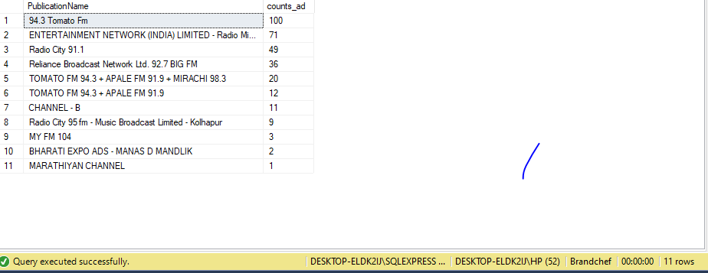

**12.NUMBER OF ADS BY YEAR**

**SELECT YEAR(RODate) AS YEARS , COUNT(*) AS NUMofAD FROM EMediaROMaster GROUP BY YEAR(RODate)**

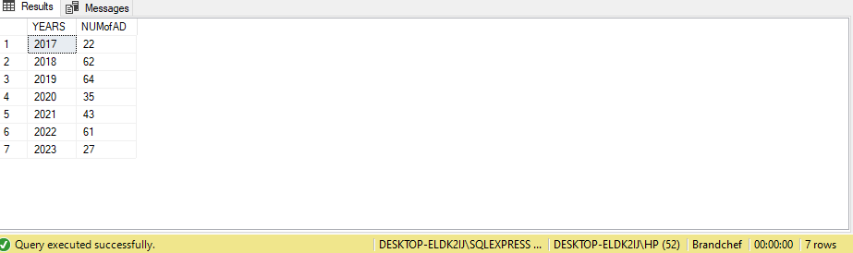

**13. AD_COUNT BY PAPERNAME**

**SELECT P.PaperName, COUNT(PM.FKPaperId)AS AD_COUNTS FROM PaperMaster AS P**

**INNER JOIN PMediaROMaster AS PM ON P.Id = PM.FKPaperId**

**GROUP BY P.PaperName ORDER BY AD_COUNTS DESC**

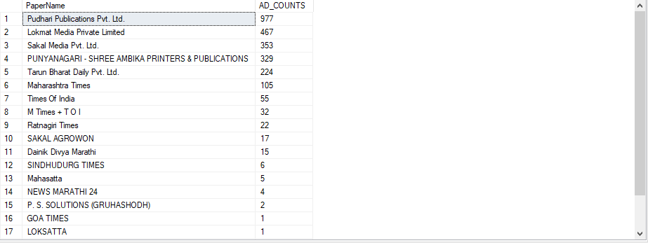

**14.**

**A] GST PAID FOR YEAR - EMIDEA**

**SELECT YEAR(RODate) as YEARS, SUM(CGSTAmount + SGSTAmount+ IGSTAmount) AS GST FROM EMediaROMaster GROUP BY YEAR(RODate)**

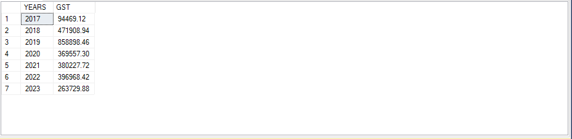

**B] GST PAID FOR YEAR - PMIDEA**

**SELECT YEAR(RODate) as YEARS, SUM(GSTAmount) FROM PMediaROMaster GROUP BY YEAR(RODate)**

